APPENDIX 2: COMPREHENSIVE MODERATION REPORT


COMPREHENSIVE MODERATION REPORT (3 sections)

SECTION 1 (Pre-assessment): Jointly completed by the Examiner & Subject Moderator/s

ASSESSMENT  : | First semester: |  | Second semester: |  | Full year: | X | YEAR: | 202

Examiner: | John Meyer | Assessment No: | No.1
Internal Moderator: | N.Mayila | HEQF level of subject: | 6
External Moderator: | R. Conning | Level of subject: (e.g. YR 1, YR 2 etc): | YR 2
Subject name: | Prehospital Medical Emergency 2 | Subject Code: | PHE261
Qualification | DIPLOMA EMC | Qualification code: | D2EMCA
Assessment Date:

Types of questions (or project assessment criteria) used in this assessment task | % Weighting across task |  | Poor | Adequate | Good
Simple recall of facts, simple processes and short definitions for example typical multiple choice questions which require students to, for example, name a process, component (the upper arm muscle is …) or amount (the longest river in Africa is …) from memory without having to perform any interpretation. | 10 | Alignment with HEQF level descriptors | 0 | 1 | 2 X
 | 10 | Alignment with subject outcomes | 0 | 1 | 2  X
Complex recall of extended definitions, complex processes and explanations which would also not require interpretation but the question would require a longer more detailed answer, for example giving a related account of steps to set up a business or perform a fault analysis. | 10 | Integration of critical cross- field outcomes | 0 | 1 | 2  X
Types of questions (or project  assessment criteria) used in this assessment task | % Weighting across task |  | Poor | Adequate | Good
Application of knowledge to solve simple, familiar problems which would involve few variables and the task would be very similar to what had been taught (for example a simple calculation or case study analysis). The student would still, however, be required to analyse the problem into its components and to synthesise knowledge to reach a solution, though at a simple level. | 80 | Clarity of instructions and questions | 0 | 1 | 2  X
Application of knowledge to solve more complex and unfamiliar problems. This is |  | Accessibility of language | 0 | 1 | 2

distinguished from more simple problem solving where there are more variables and/or the student has to apply their knowledge to a new context, rather than one that has previously been taught. Furthermore, the student would be required to perform a more difficult analysis of what the problem involves and what knowledge would need to be synthesised to address a solution (this could be a complex, multi-stage calculation or a more challenging case study). | 0  0 |  |  |  | X
Simple critical analysis in which the student is asked to pass judgement, give reasoned opinion on and make suggestions towards, for example, an issue, procedure or approach with reference to the typical knowledge and procedures of the field. This could be done through asking students to comment on issues or approaches in a short case study. At lower levels (for example year 1) this would typically be similar to what has been taught involving relatively few variables. | 0  0 | Time allocation | 0 | 1 | X  2
More complex critical analysis would involve students’ operating in a relatively unfamiliar or new context with an increased number of variables.
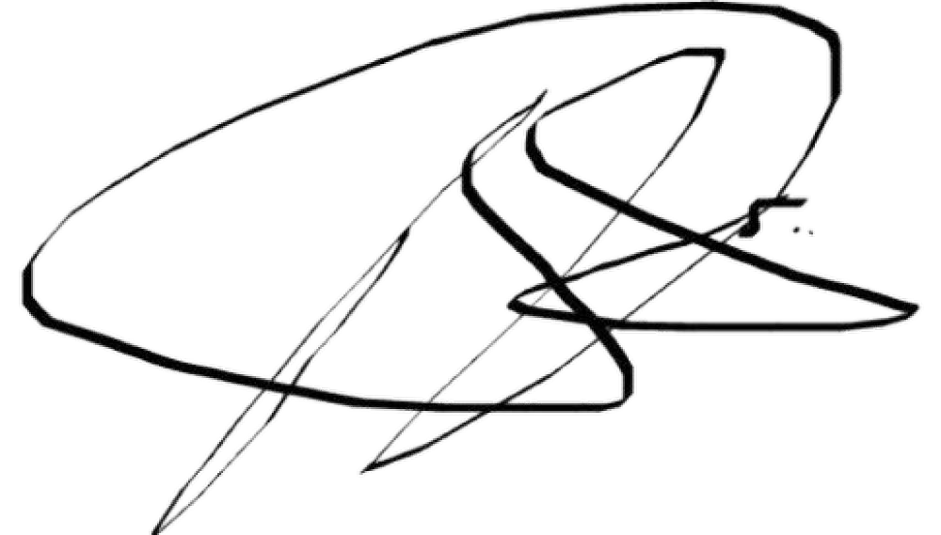
[Adapted from Bloom’s taxonomy to incorporate the SAQA level descriptors]
Table: levels of complexity of assessments

1. | Was the assessment task moderated before the students completed the assessment?
 | Comments: | YES
2. | Is the assessment task (test, oral, practical, project) and memo/assessment criteria set at an appropriate HEQSF level? | YES
2. | Comments:
3. | Is the allocation of marks in proportion to the complexity of the questions?
3. | Comments: | YES

DECLARATION: Consensus has been reached between the Examiner and the moderator/s
NAME: Examiner (please print) | SIGNATURE | DATE
John Meyer |  | 4 May 2024
NAME: Internal Moderator (please print) | SIGNATURE | DATE
 |  | 4 May 2024
NAME: External Moderator (please print) | SIGNATURE | DATE
R.Conning |  | 4 May 2024

SECTION 2 (Post-assessment): Jointly completed by the Examiner & Subject Moderator/s
 | [Subject Code] PHE261 | [Subject Name] Medical 2
 | Total number of (reg.) candidates | 61 | No. of candidates  absent: | 0
 | Highest mark obtained: | 89 | No. of passes: | 47
 | Percentage pass: | 77% | Average  mark (%): | 60%
 | Type of assessment: | Theory Assessment

1. | Which types of questions/project assessment criteria (see Table 1) did most students not meet?
 | Comments:. The students struggled with the essay questions
2. | Comment on the pass-rate (above), and any other indicators (e.g. student evaluations) as to how students fared in this assessment.
2. | Comments: The scored poorly on the essasy question , intervention needed
3. | Have the pass-rate and other indicators changed significantly compared to previous assessments this semester?
3. | Comments: 1st Assessment
4 | What was done differently in the approach to this subject this semester/year, and how effective was it?
 | Comments: I believe discipline and a positive mindset or culture within the student cohort was the powerful drivers of their success.
5 | What should be done differently next time this subject is taught and assessed?
 | Comments: More practice questions needed
6 | Is the marking of the assessor up to standard, accurate, fair, consistent?
 | Comments: Yes
7 | Is the marking of the assessor recommended for acceptance?
 | Comments: Yes
8 | Please comment on the following:
The extent to which the assessment tasks cover the outcomes/content of the subject, in proportion to its relative importance.
Yes
Whether the assessment tasks are at the appropriate level of difficulty (standard) for the exit level of the subject.
Appropriate level
Whether the assessment tasks have industry/professional relevance.
Yes , all topics covered aligned to international standards
The reliability of the assessment process (i.e. consistent marking, accurate results, detailed memorandum, comprehensive assessment criteria). Consistent
The validity of the assessment methods and instruments (comment on whether it measures the selected content/practical skills and learning outcomes it intends to).

Appropriate

The quality of the feedback given to the students (not required for final summative assessment).
Student asked for more time and additional
Are any general adjustments of the marks recommended?
Specify:

DECLARATION: Consensus has been reached between the Examiner and the moderator/s

NAME: Examiner (please print) | SIGNATURE | DATE
John Meyer |  | 30 May 2024
NAME: Internal Moderator (please print) | SIGNATURE | DATE
N.Mayila |  | 30 May 2024
NAME: External Moderator (please print) | SIGNATURE | DATE
R.Conning

SECTION 3: To be completed by the External Moderator (where applicable)
[Sections 1 and 2 to be included for the external moderator]

Please comment on the following:
The extent to which the assessment tasks cover the outcomes/content of the subject, in proportion to its relative importance.
Whether the assessment tasks are at the appropriate level of difficulty (standard) for the exit level of the subject.
Whether the assessment tasks have industry/professional relevance.
The reliability of the assessment process (i.e. consistent marking, accurate results, detailed memorandum, comprehensive assessment criteria).
The validity of the assessment methods and instruments (comment on whether it measures the selected content/practical skills and learning outcomes it intends to).
The quality of the feedback given to the students (not required for final summative assessment).
How the qualification compares to best practice/innovative practice nationally and internationally
The extent to which the qualification standards are in accordance with HEQSF, SAQA level descriptors and professional/industrial council standards and/or significant employer requirements
Any recommendations for changes and/or improvements in the best interests of the qualification, CPUT staff and ensuring the capability profile of our students.
Are any general adjustments of the marks recommended?
Specify:

NAME: External Moderator (please print) | SIGNATURE | DATE
R.Conning
NAME: Examiner (please print) | SIGNATURE | DATE
J.Meyer
NAME: Head of Department (please  print) | SIGNATURE | DATE

